Tableau Session 33

Assignment: 17.1

1. Open the Super Store dashboard.twbx

Answer : Go to Tableau start page.

Go to Source data Source

Select the sample – Superstore data

Click on Dashboard in the tableau tab

Click on Extrat super store data

2. Create a bar graph to show the Total Sales across customer segments for various regions

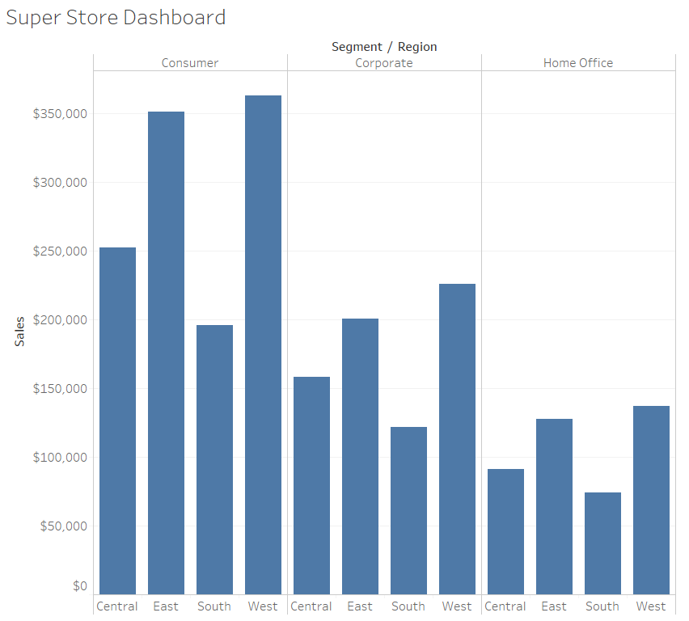

3. Segregate each region with different colors

